8).Create a simple cloud web application for student counselling system using any Cloud Service Provider to demonstrate SaaS with the fields of student name, age, address, phone, subjects studied, Year of passing, percentage of marks, domain interest, etc.

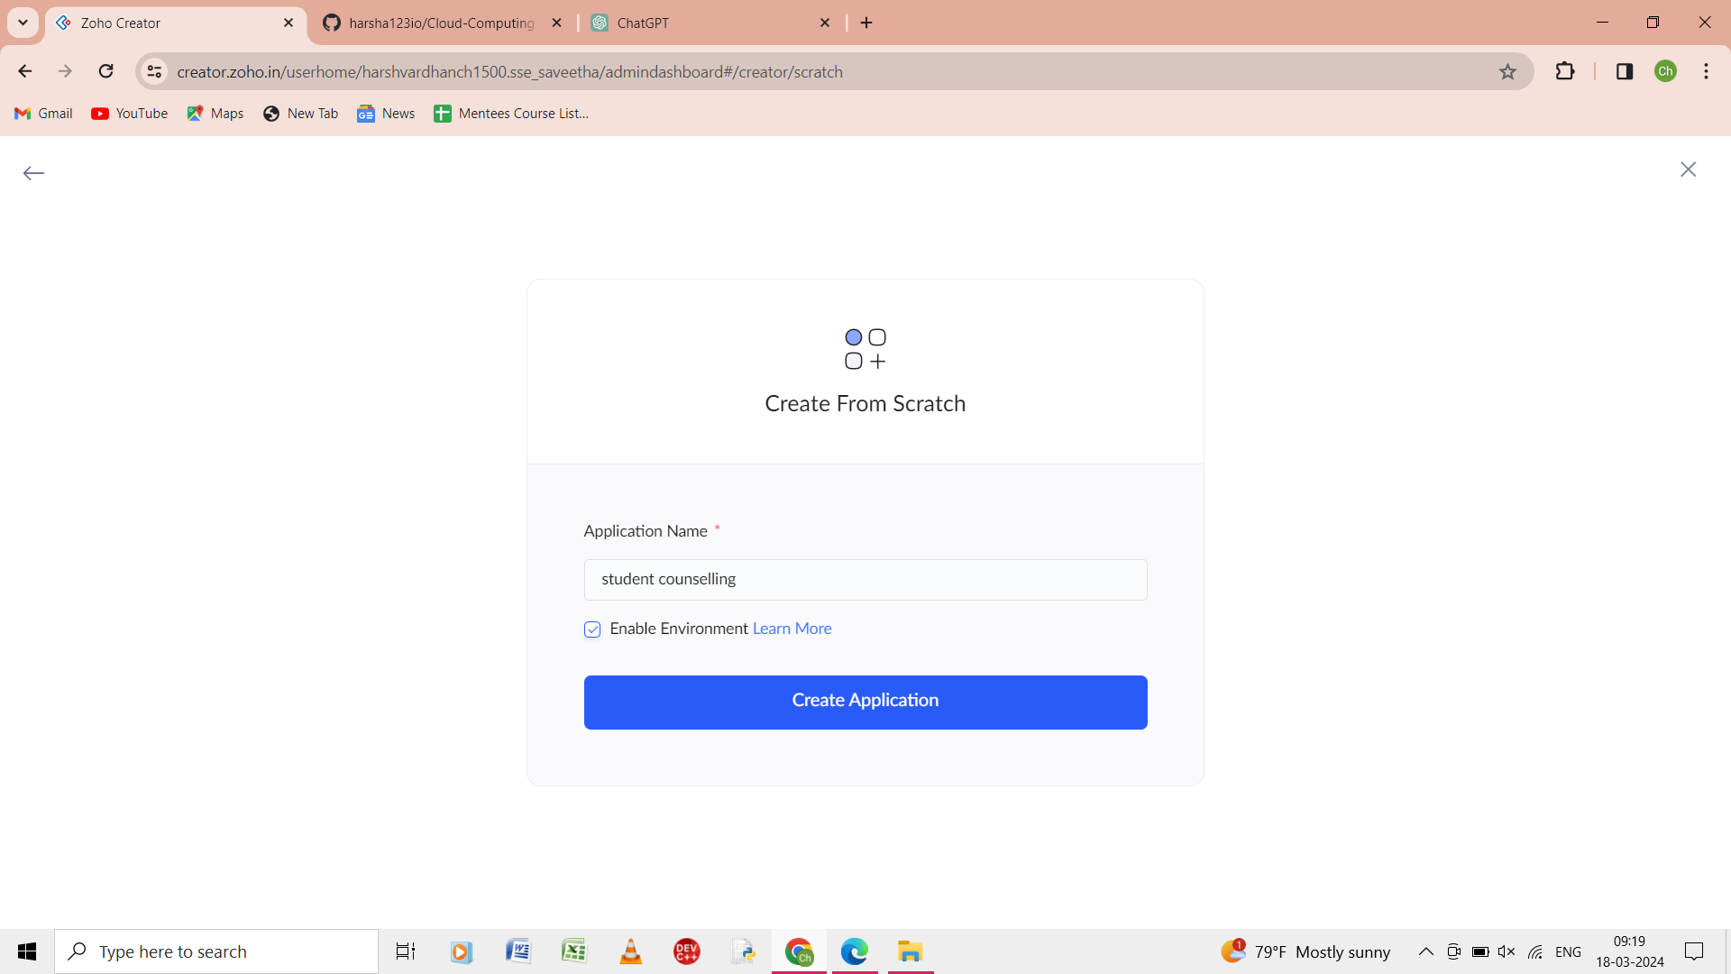

Step 1: from the scratch give the nae of the application as student counseling.

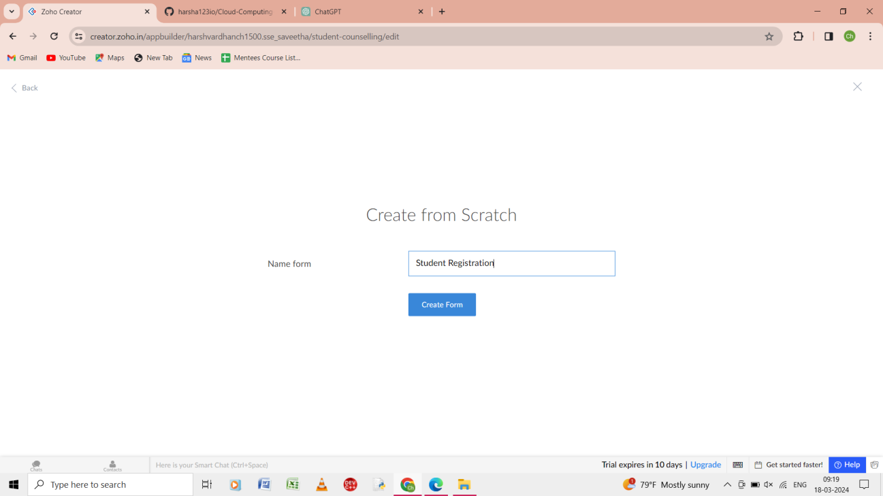

Step 2: from the scratch give the form of the name as student registration

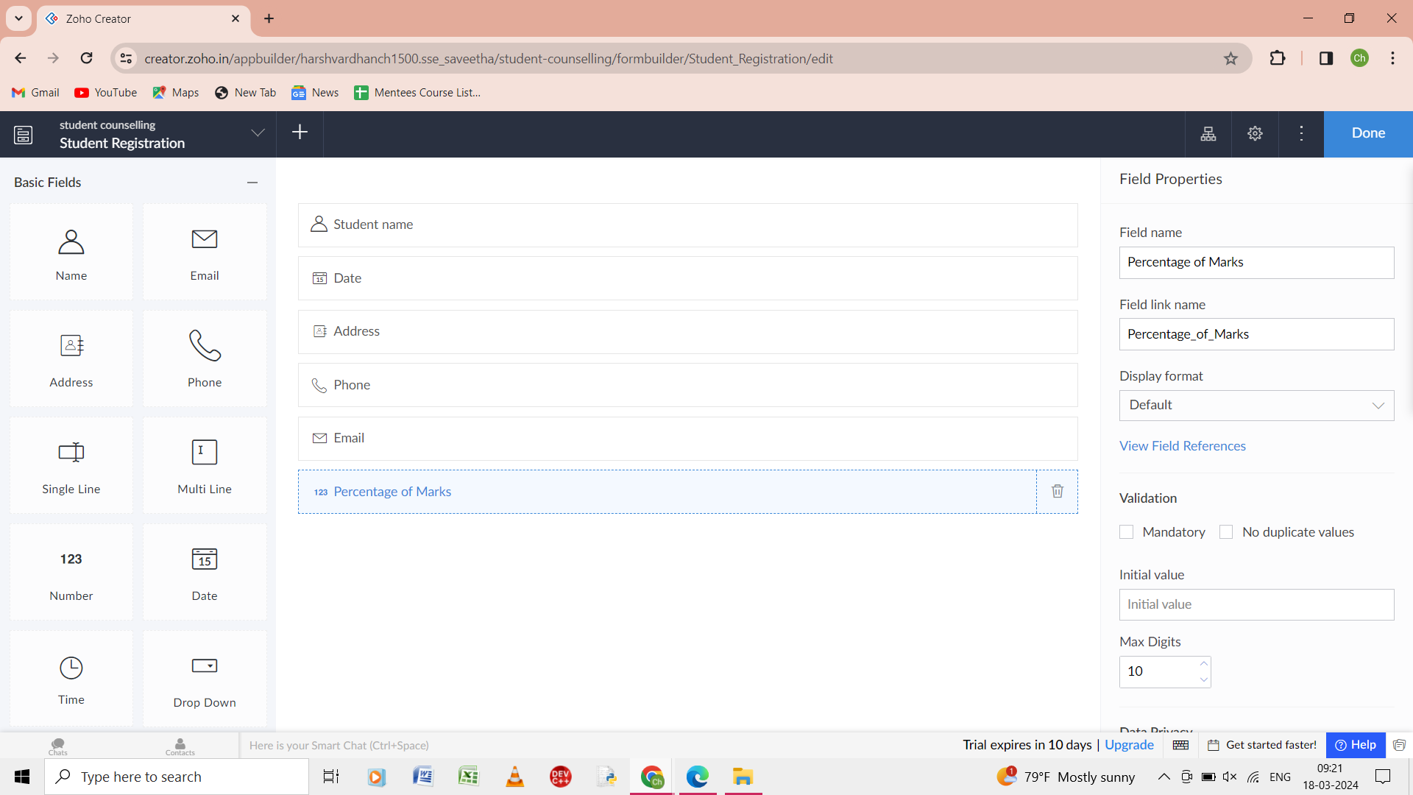

Step 3: in the student registration from give the details as student name, dare, address, phone, email, percentage of marks.

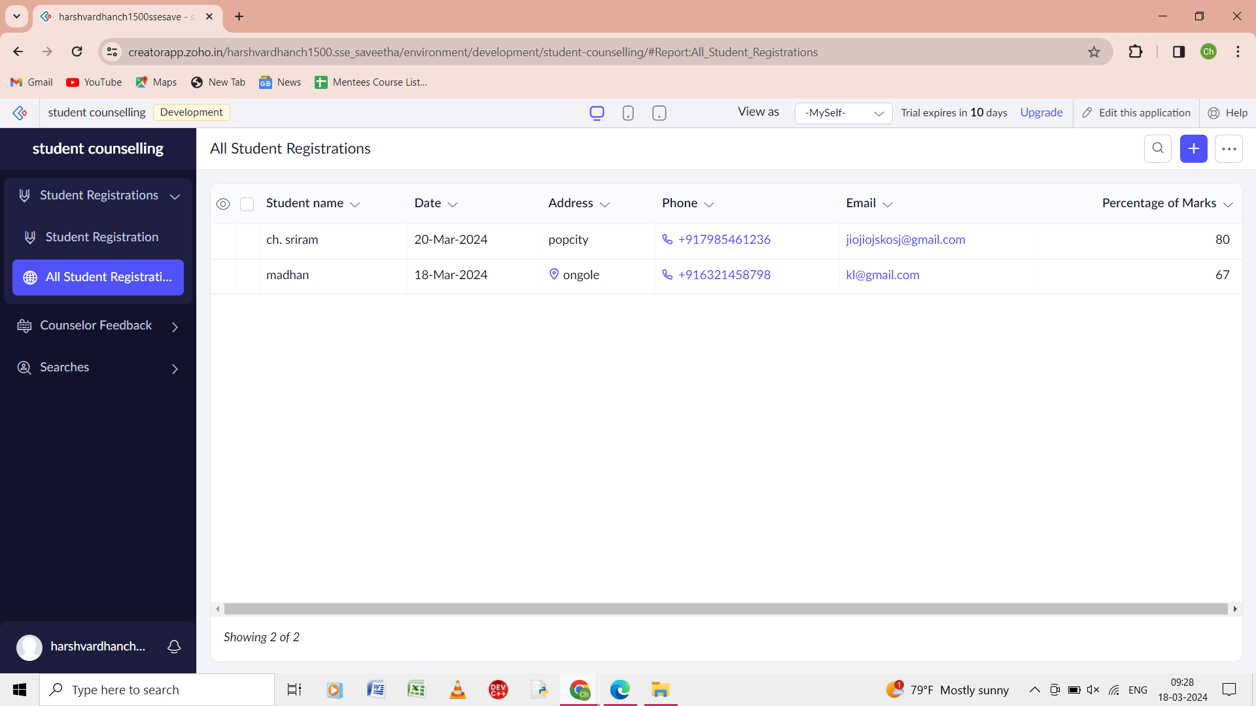

Step 4: the report of all the student registration .

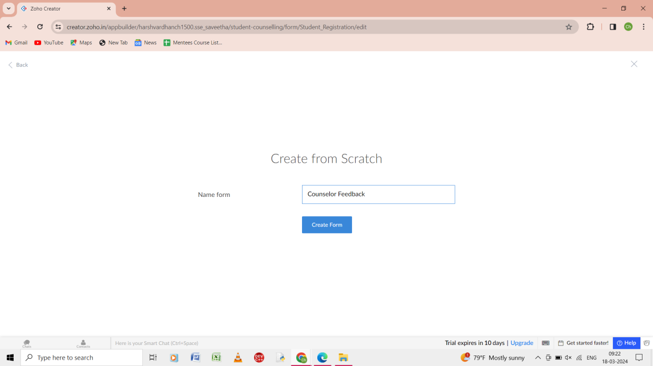

Step 5: from the scratch give the form name as counseller feedback.

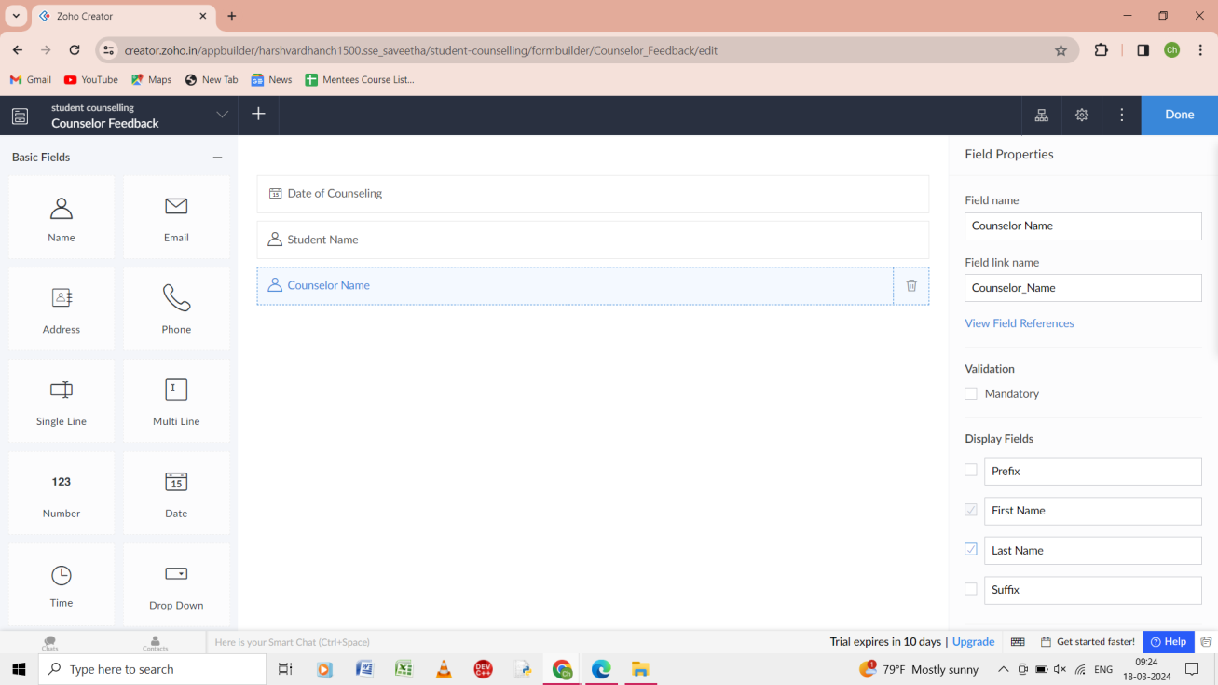

Step 6: in the counseller form give the details as date of counseling , student name,counseler name.

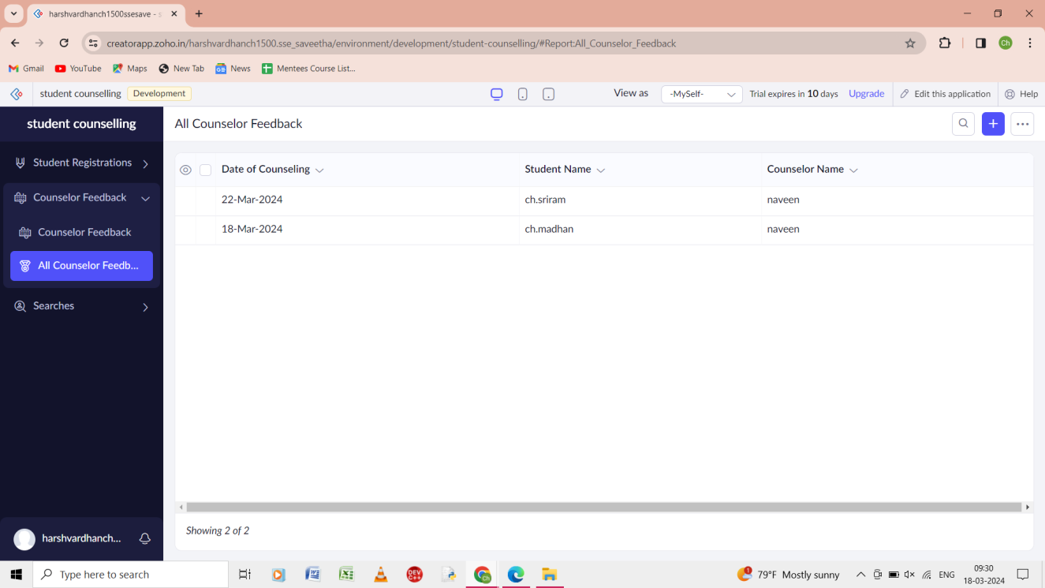

Step 7:the report of the all the cousenelor of the form.

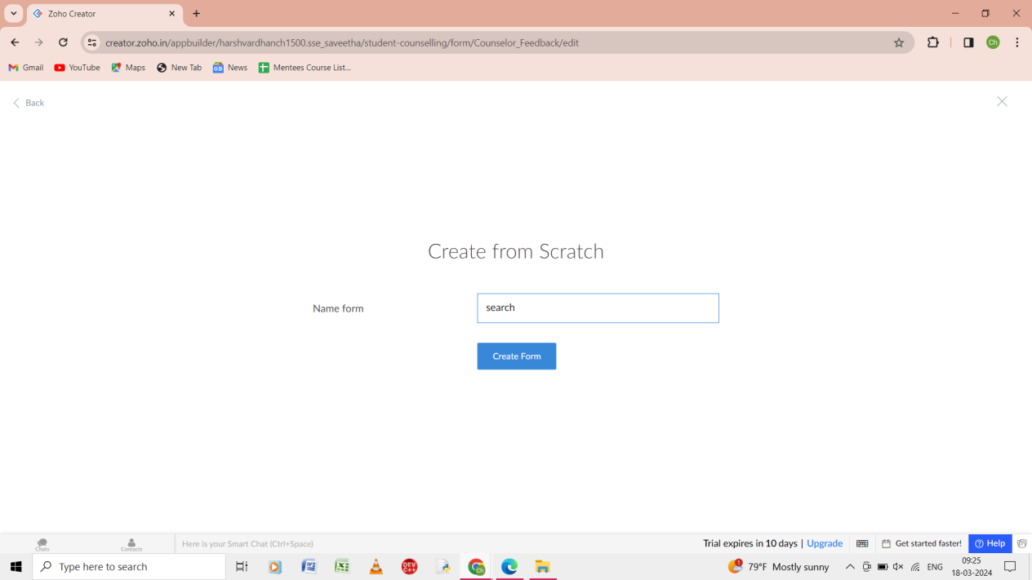

Step 8: from the scratch give the name of the form as search.

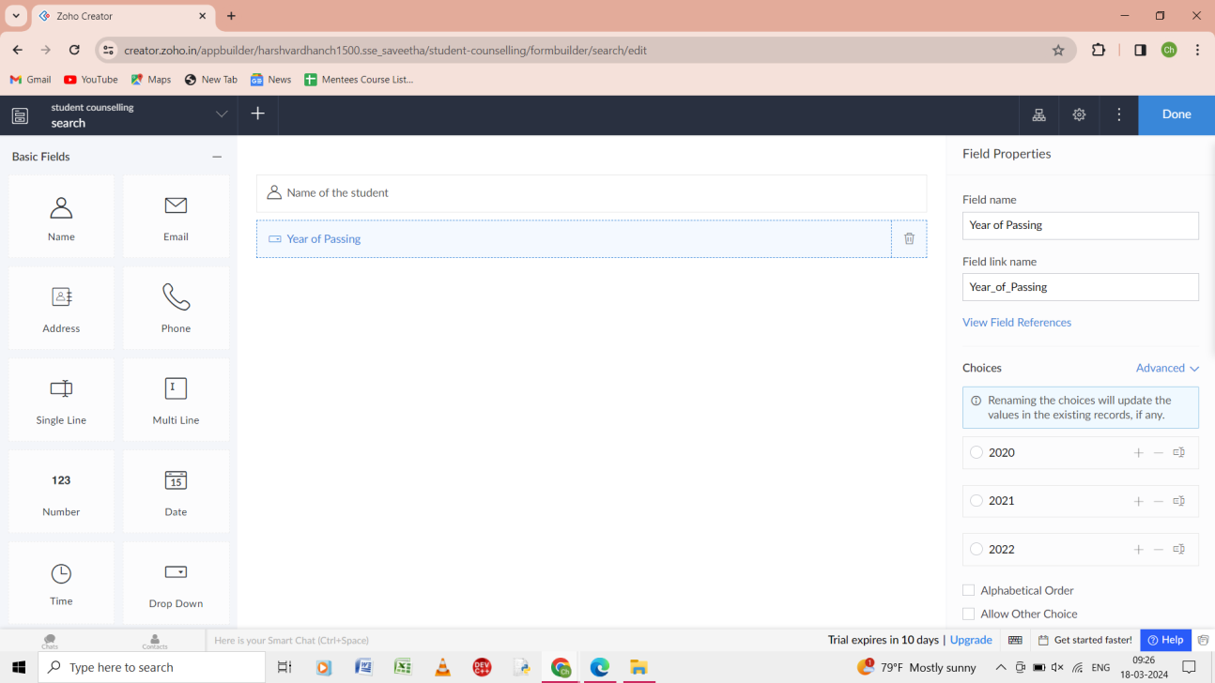

Step 9: from the form of the search give the name of the student, year of passing.

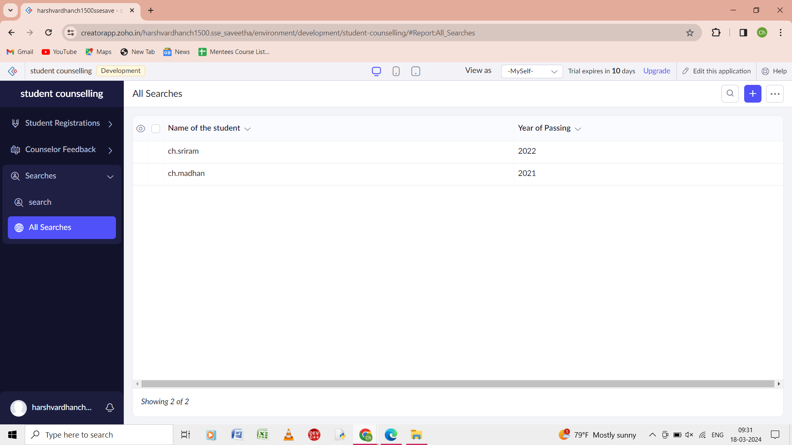

Step 10: the report of the all the search of the form is shown.